**Experiment no:** 06

**Experiment name:** Implementation of binary parallel Adder using IC 74283.

**Theory:**

A single full adder performs the addition of two one bit numbers and an input carry. But a Parallel Adder is a digital circuit capable of finding the arithmetic sum of two binary numbers that is greater than one bit in length by operating on corresponding pairs of bits in parallel. It

consists of**full adders connected in a chain** where the output carry from each full adder is connected to the carry input of the next higher order full adder in the chain.**A n bit parallel adder requires n full adders to perform the operation.** So for the two-bit number, two adders are needed while for four bit number, four adders are needed and so on

**Circuit implementation:**

**4 Bit Binary Adder:**

An Example: 7+2=11 (1001)

7 is realized at A3 A2 A1 A0 = 0111

2 is realized at B3 B2 B1 B0 = 0010

Sum = 1001

IC 7483 Pin Diagram:

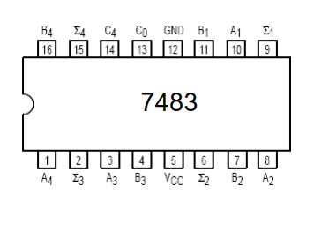

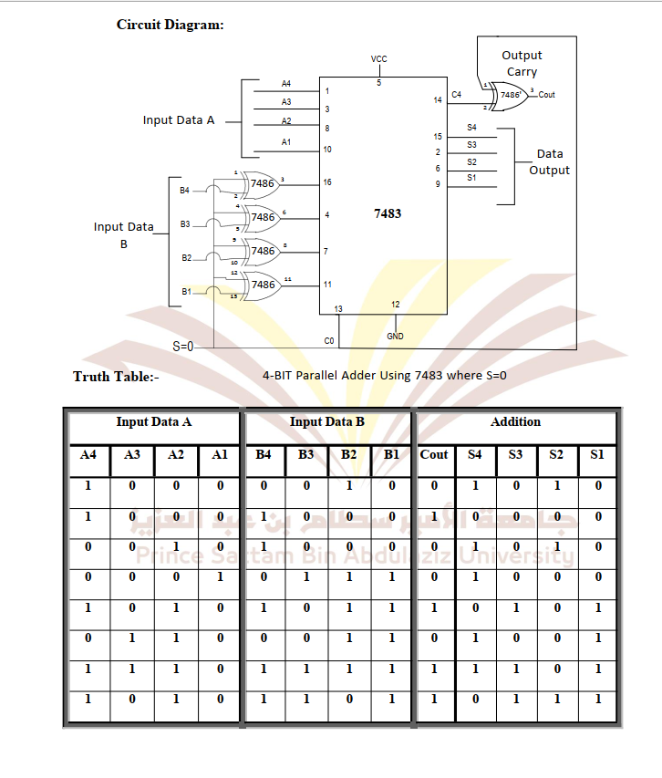

**Discussion:**

1. As shown in the figure, firstly the full adder FA1 adds A1 and B1 along with the carry C1 to generate the sum S1 (the first bit of the output sum) and the carry C2 which is connected to the next adder in chain.
2. Next, the full adder FA2 uses this carry bit C2 to add with the input bits A2 and B2 to generate the sum S2(the second bit of the output sum) and the carry C3 which is again further connected to the next adder in chain and so on.
3. The process continues till the last full adder FAn uses the carry bit Cn to add with its input An and Bn to generate the last bit of the output along last carry bit Cout.

**Advantages of parallel Adder/Subtractor –**

1. The parallel adder/subtractor performs the addition operation faster as compared to serial adder/subtractor.
2. Time required for addition does not depend on the number of bits.
3. The output is in parallel form i.e all the bits are added/subtracted at the same time.
4. It is less costly.

**Result**: Binary 4-bit full adder is studied and verified